МИНИСТЕРСТВО НАУКИ И ВЫСШЕГО ОБРАЗОВАНИЯ РОССИЙСКОЙ ФЕДЕРАЦИИ

ФЕДЕРАЛЬНОЕ ГОСУДАРСТВЕННОЕ БЮДЖЕТНОЕ ОБРАЗОВАТЕЛЬНОЕ УЧРЕЖДЕНИЕ ВЫСШЕГО ОБРАЗОВАНИЯ

# «БЕЛГОРОДСКИЙ ГОСУДАРСТВЕННЫЙ ТЕХНОЛОГИЧЕСКИЙ УНИВЕРСИТЕТ им. В. Г. ШУХОВА»

**(БГТУ им. В.Г. Шухова)**

Кафедра программного обеспечения вычислительной техники и автоматизированных систем

Лабораторная работа №8

по дисциплине «Теория надежности» тема: «Анализ живучести сетей»

Выполнил: ст. группы ВТ-32 Черных Воскобойников И. Проверил: Кабалянц П.С.

Белгород 2021 г.

# Данные варианта



i = 1, j = 0, k = 0

# Выполнение работы

import networkx as nx  
import matplotlib.pyplot as plt  
import random as rand  
class Graph:  
   
 def __init__(self, nodes_count: int):  
 self.edges = []  
 self.powers = {node: 0 for node in range(nodes_count)}  
 self.claster_coefs = {node: 0 for node in range(nodes_count)}  
   
 def add_node(self):  
 self.powers[self.get_nodes_count()] = 0  
  
 def add_edge(self, a, b):  
 if a < b:  
 self.edges.append([a, b])  
 else:  
 self.edges.append([b, a])  
 self.powers[a] += 1  
 self.powers[b] += 1  
  
 def random_add_edge(self, p: float, a, b):  
 if rand.random() < p:  
 self.add_edge(a, b)  
  
 def get_nodes_count(self):  
 return len(self.powers)  
  
 def get_power(self, node) -> int:  
 return self.powers[node]  
  
 def get_sum_of_powers(self) -> int:  
 return sum(self.powers)  
  
  
 def get_claster_coef(self, node) -> None:  
  
 node_neighbours = list()  
  
 for edge in self.edges:  
 if edge[0] == node:  
 node_neighbours.append(edge[1])  
 elif edge[1] == node:  
 node_neighbours.append(edge[0])  
  
 neighbours_count = len(node_neighbours)  
 max_count = neighbours_count*(neighbours_count - 1)/2  
 if max_count == 0:  
 return None  
  
 current_count = 0  
 for edge in self.edges:  
 if edge[0] == node or edge[1] == node:  
 continue  
 elif edge[0] in node_neighbours and edge[1] in node_neighbours:  
 current_count += 1  
 claster_coef = current_count/max_count  
  
 self.claster_coefs[node] = claster_coef  
 return claster_coef  
  
 def calculate_claster_coefs(self):  
 nodes = self.get_nodes_count()  
 for node in range(nodes):  
 self.get_claster_coef(node)  
  
  
*# Выводит изображения графа.* def visualize(self):  
 graph = nx.Graph()  
 graph.add_edges_from(self.edges)  
 nx.draw_networkx(graph)  
 plt.show()  
  
 @staticmethod  
 def random_graph(nodes_count: int, p: float):  
 graph = Graph(nodes_count)  
  
 for i in range(nodes_count - 1):  
  
 for j in range(i + 1, nodes_count):  
 graph.random_add_edge(p, i, j)  
 return graph  
  
 def do_build(self, n_end: int):  
 n = len(self.powers)  
 for new_node in range(n, n_end):  
 sum_of_powers = self.get_sum_of_powers()  
 self.add_node()  
 for node in range(new_node):  
 p_add = self.get_power(node) / sum_of_powers  
 self.random_add_edge(p_add, new_node, node)  
 self.edges.sort(key=lambda edge: edge[0])  
  
def out_powers_func(graph: Graph, n_end: int):  
  
 y_dict = { power: 0 for power in range(n_end) }  
 for (node, power) in graph.powers.items():  
 y_dict[power] += 1  
 for power in range(len(y_dict) - 2, -1, -1):  
 y_dict[power] += y_dict[power + 1]  
 y_dict.pop(0)  
  
 flag = True  
 while flag:  
 to_new = False  
 for power in y_dict.keys():  
 if y_dict[power] == 0:  
 y_dict.pop(power)  
 to_new = True  
 break  
 if not to_new:  
 flag = False  
 plt.plot(y_dict.keys(), y_dict.values())  
 plt.show()  
  
def out_clasters_func(graph: Graph, n_end: int):  
  
 y_dict = dict()  
 for (node, coef) in graph.claster_coefs.items():  
 y_dict[coef] = 1  
 keys_list = sorted(list(y_dict.keys()))  
 for coef in range(len(y_dict) - 2, -1, -1):  
 y_dict[keys_list[coef]] += y_dict[keys_list[coef + 1]]  
  
 plt.plot(keys_list, [y_dict[key] for key in keys_list])  
 plt.show()  
if __name__ == **'__main__'**:  
 i = 1  
 j = 0  
 k = 0  
  
 n = 10  
  
 n_end = 1000  
  
 p = i/(i + j + k)  
 if p < 1/2:  
 p += 1/2  
  
 graph = Graph.random_graph(n, p)  
 graph.calculate_claster_coefs()  
 out_powers_func(graph, n)  
 out_clasters_func(graph, n)  
 graph.visualize()  
  
 graph.do_build(n_end)  
 graph.calculate_claster_coefs()  
 out_powers_func(graph, n_end)  
 out_clasters_func(graph, n_end)  
 graph.visualize()

Результаты работы программы:

# При n = 10

1. Граф:

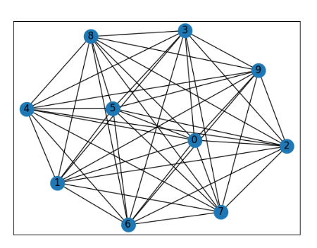

# При n = 1000

Зависимость числа вершин от степени:

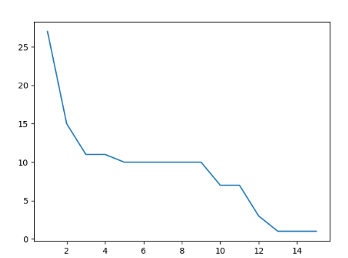

Зависимость числа вершин от коэффициента кластеризации:

